Is it a DAG? (Directed Acyclic Graph)

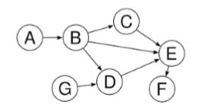Directed graph and multiple edges are given as a single component. Determine whether the graph is a Directed Acyclic (DAG) or not. In this case, it is required to determine if the graph is a cyclic graph (Contains Cycles) which contains a path from at least one node back to itself, see **the figures below.**

**Is a DAG Graph**

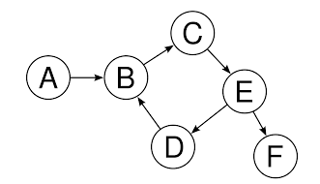

**Is NOT a DAG**

# Function to Implement

static bool IsDAG(string[] vertices, KeyValuePair<string, string> [] edges)

IsItDAG.cs includes this method.

Your function has vertices array (1 ≤ size ≤ 100,000) in the graph and edges as a list of KeyValuePair<string, string>, where **key: sourceVertex, value: destVertex**

## Example

3 // Vertices Count

2 // Edges Count

A1,A2,A3 // Vertices

A1,A2 // Edges

A2,A3

true // IsDAG

# C# Help

## Lists

### Creation

To create a list of a certain type (e.g. string)

List<string> myList1 = new List<string>() //default initial size

List<string> myList2 = new List<string>(**initSize**) //given initial size

### Manipulation

1. myList1.Count 🡺 get actual number of items in the list
2. myList1.Sort()🡺 Sort the elements in the list (ascending)
3. myList1[index]🡺 Get/Set the elements at the specified index
4. myList1.Add(“myString1”)🡺 Add new element to the list
5. myList1.Remove(“myStr1”)🡺 Remove the 1st occurrence of this element from list
6. myList1.RemoveAt(index)🡺 Remove the element at the given index from the list
7. myList1.Contains(“myStr1”)🡺 Check if the element exists in the list

## Dictionary (Hash)

### Creation

To create a dictionary of a certain key (e.g. string) and value (e.g. array of strings)

//default initial size

Dictionary<string, string[]> myDict1 = new Dictionary<string, string[]>();

//given initial size

Dictionary<string, string[]> myDict2 = new Dictionary<string, string[]>(**size**);

### Manipulation

1. myDict1.Count 🡺 Get actual number of items in the dictionary
2. myDict1[key] 🡺 Get/Set the value associated with the given key in the dictionary
3. myDict1.Add(key, value)🡺 Add the specified key and value to the dictionary
4. myDict1.Remove(key)🡺 Remove the value with the specified key from the dictionary
5. myDict1.ContainsKey(key)🡺 Check if the specified key exists in the dictionary

## Creating 1D array

int [] array = new int [size]

## Creating 2D array

int [,] array = new int [size1, size2]

## Length of 1D array

int arrayLength = my1DArray.Length

## Length of 2D array

int array1stDim = my2DArray.GetLength(0)

int array2ndDim = my2DArray.GetLength(1)

## Sorting single array

Sort the given array in ascending order

Array.Sort(items);

## Sorting parallel arrays

Sort the first array "master" and re-order the 2nd array "slave" according to this sorting

Array.Sort(master, slave);